**DAILY ONLINE ACTIVITIES SUMMARY**

|  |  |  |  |  |  |  |  |  |
| --- | --- | --- | --- | --- | --- | --- | --- | --- |
| **Date:** | **18/05/2020** | | | | | **Name:** | **V ANJANA PAI** | |
| **Sem & Sec** | **IV sem & B section** | | | | | **USN:** | **4AL18CS094** | |
| **Online Test Summary** | | | | | | | | |
| **Subject** | | **COMPLEX ANALYSIS, PROBABILITY AND STATISTICAL METHODS** | | | | | | |
| **Max. Marks** | | **30** | | **Score** | | | **-** | |
| **Certification Course Summary** | | | | | | | | |
| **Course** | **PYTHON FOR MACHINE LEARNING** | | | | | | | |
| **Certificate Provider** | | | **Great learning academy** | | **Duration** | | | **5 hours** |
| **Coding Challenges** | | | | | | | | |
| **Problem Statement 1: Given an array of distinct integers. The task is to count all the triplets such that sum of two elements equals the third element.**  **Problem Statement 2: Write a C program to check whether the two strings are Anagram or not.** | | | | | | | | |
| **Status: executed** | | | | | | | | |
| **Uploaded the report in GitHub** | | | | | **YES** | | | |
| **If yes Repository name** | | | | | **Lockdown-coding** | | | |
| **Uploaded the report in slack** | | | | | **YES** | | | |

Online Test Summary: 18MAT41 test was scheduled from 9:30 am t0 10:00 am And the test scores are not yet received. The portion for the IA was 4th module there were 30 questions and the time assigned was 30 minutes the questions were mcq type.

Online Certification course Summary: I have opted my Online Certification Course from Great learning academy the course which I have opted is Python for Machine Learning. Course contains assessments and practice assessments the faculty is Dan Mitchell-Assistant professor, university of Minnesota; Industrial and Systems Engineering. Today I have gone through the python introduction and I came to know that python is easy to learn, powerful programming language. We can also use python when our data analysis task needs to be incorporated into a production database. B Being a full-fledged programming language, it’s a great tool to implement algorithms for production use.

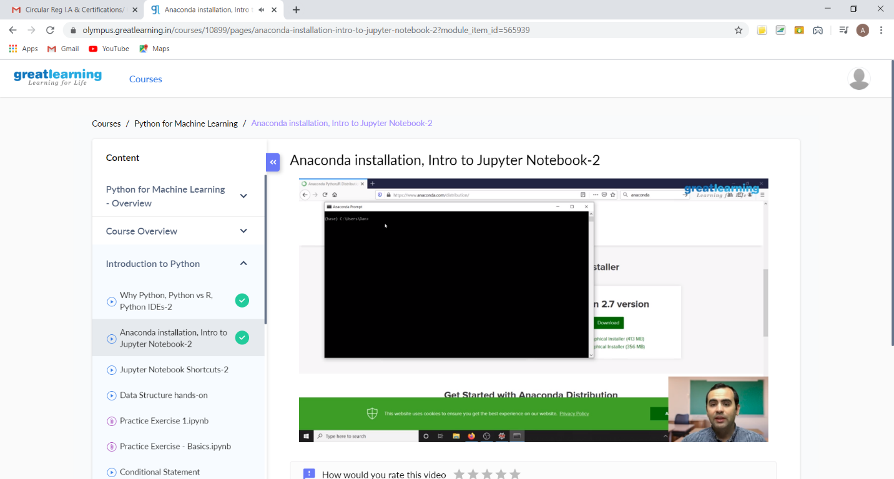

**In this video I came to know what exactly is python programming language and what is the difference between very two well-known languages python and R. I also known that python is an open source and there are tons of packages freely available and there are many python IDE’s like PyCharm, jupyter notebooks, Spyder etc. And also learnt about Anaconda installation and about jupyter notebook. Anaconda is available free of coast and it is having 2 versions. It is one of the platforms to execute python programs.**

**Online coding Summary: Today I had received two programs from prof. Venkatesh CSE Dept. The two programs were i) to count triplets and ii) to check the given strings are anagram or not. I have written both the programs and uploaded it to my GitHub repository.**

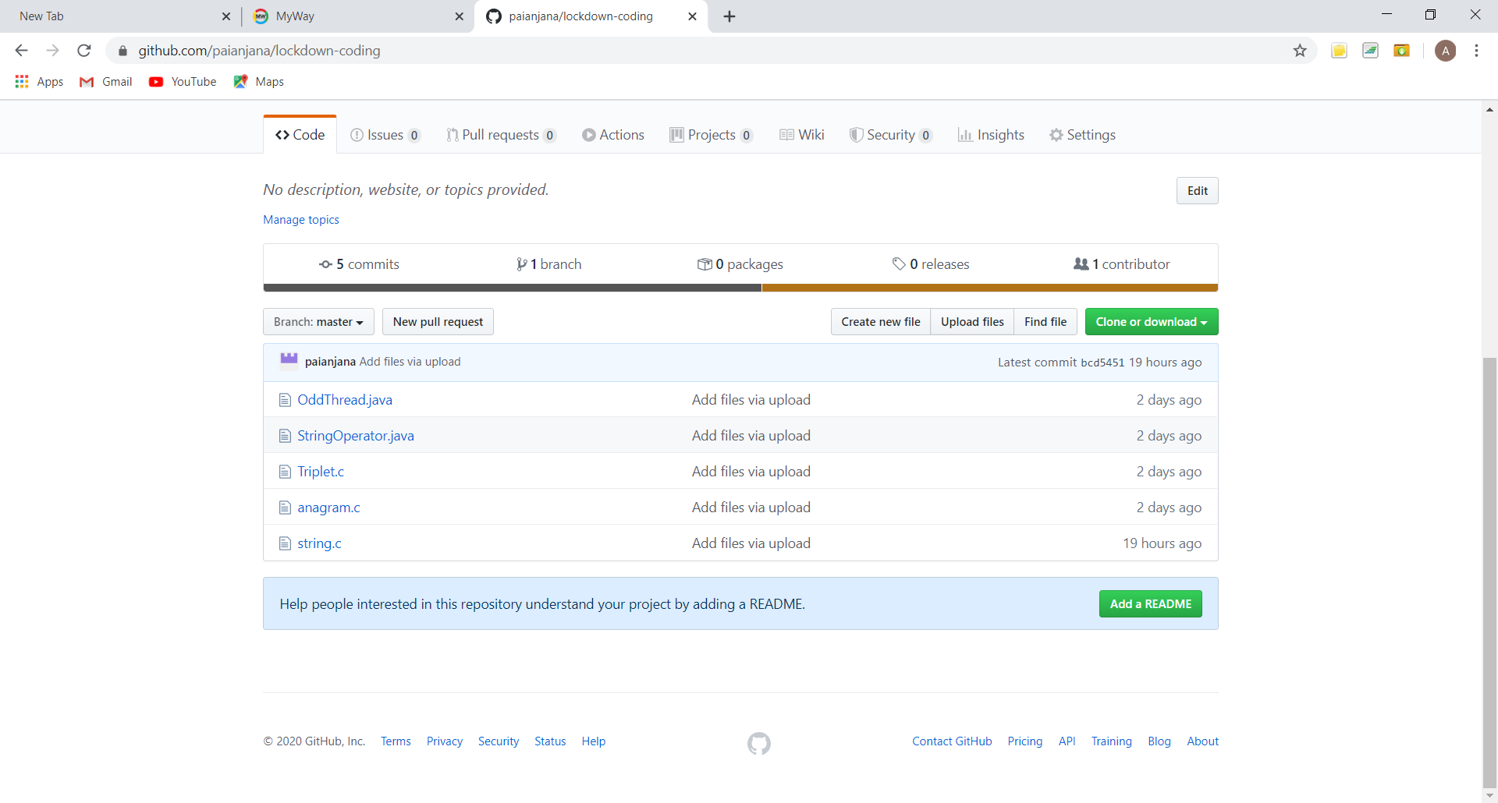

**This is my repository snap shot where I have uploaded both the programs with folder name as Triplets.c and anagram.c.**